Director’s Message

Calendar
• • •

Nov 19 Parent teacher conferences
Nov 19-23 Thanksgiving Break
Dec 24-Jan 4 Christmas Break
Jan 21 Martin Luther King Day
Jan 25 End of Semester
Feb 18 President’s Day
Feb 22 Career Day
Mar 22 End of 3rd Quarter
Mar 25-29 Spring Break
May 27 Memorial Day
June 7 Last Day of School

KTEC’s Newsletter
11/16/2018

By: Colby Mattila
The 2018-2019 school year is off to a great start! Over the summer we were able to send two students to National SkillsUSA, one in Construction and the other in Auto body Collision and Refinishing. Our Auto body student took 11th at Nationals and our Construction student came in 2nd in the Nation! We are very proud of both of them.
KTEC has seen some changes over the summer and we are excited to introduce some new additions to the staff, our Administrative Assistant Cristine Steckman and our College and Career Advisor Kristin Parker. We also were able to add two new programs this year.
Millwright with Corey Pettit:
This is a two year program that prepares students for employment as industrial plant maintenance mechanics or millwrights. Students learn the basics of maintenance, fabrication, installation, and alignment of equipment used in modern industrial and manufacturing plants.
HVAC in the Spring with Sean Sater:
This is a two year program Students will study basic HVACR systems, electricity, heating systems, local fuel codes, applied thermodynamics, refrigeration cycle, psychometrics, duct system design, and system diagnosis. These skills are taught in classroom theory and learned in hands-on lab exercises and cooperative work experiences. A general education component consisting of communication, occupational relations, and math is integrated into the program
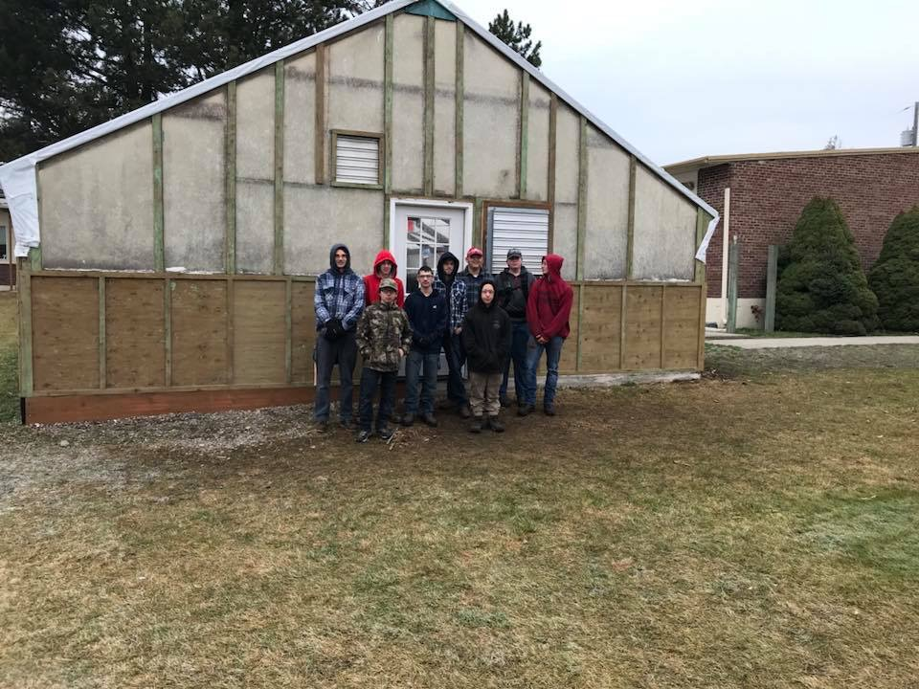
Construction Program Highlight
Instructor: Casey Syth

Students have renovated the greenhouse at New Vision High school in Post Falls. The greenhouse is used for part of their science program. It has been used regularly for many years and the weather has taken its toll. All of the plywood on the sides were rotten and falling off, the plastic was in bad condition too. Students had to work together in groups of three to four very carefully to take the greenhouse apart without affecting the structural integrity of the building. They installed new pressure treated plywood to the sides to ensure longevity of the materials and added some trim to give it more of an updated look. The students removed all of the old trim and replaced with new pressure treated trim. The students also had to put new plastic on the roof which took a lot of teamwork to ensure that it did not get damaged during the install. This was a time sensitive project that had to be done before the winter hit because they will start planting in January. All of the materials were purchased through funds made from the greenhouses plant sales.
Resort Academy Highlight – Instructor: Stacey Armstrong

It has become a tradition for the Resort Academy Program to pass out candles to spectators during the downtown lighting ceremony in Coeur d’ Alene. This year the festivities will be held on Friday, November 23, 2018 at 5:00pm and the parade will start at 8th & Sherman. The lighting ceremony will begin directly after, approximately 6:00pm. Our Resort students help the community get into the holiday spirit, while selling hot coco and cookies which are graciously donated by the CDA Resort. Funds raised will help students attend local industry tours and compete in hospitality events.

